ANIMAL SHELTER MANAGEMENT SYSTEM
Programming Techniques 1 – Mini Project

Serge DONTSA(260847242)-Stephen Espiritu-Vidian-Manuel DURAUD(261297592)
November 03 2025

- Problem Definition

- Scenario Chosen: Animal Shelter Management System
- Problem Statement: The shelter needs a system to manage animals available for adoption, track their medical records, process adoptions with eligibility verification, and manage volunteers.

- Conceptual Design

- Key Entities and Relationships: The shelter contains Animals and Volunteers. Animal is an abstract class with subclasses Dog, Cat, Bird. AdoptionForm represents adopter information. Animal has a MedicalRecord for health tracking.
- Features to Implement:
      - Core features: Adding and displaying animals, processing adoptions with verification, tracking medical records.
      - Enhancement features: Using interfaces to define adoption behavior, composition of medical records in Animal, volunteer management.
- Class Design
UML Class Diagram:
In our application, inheritance and polymorphism can be show by using an abstract Animal class and Adoptable interface as common types for diverse animal subclasses with specific behavior
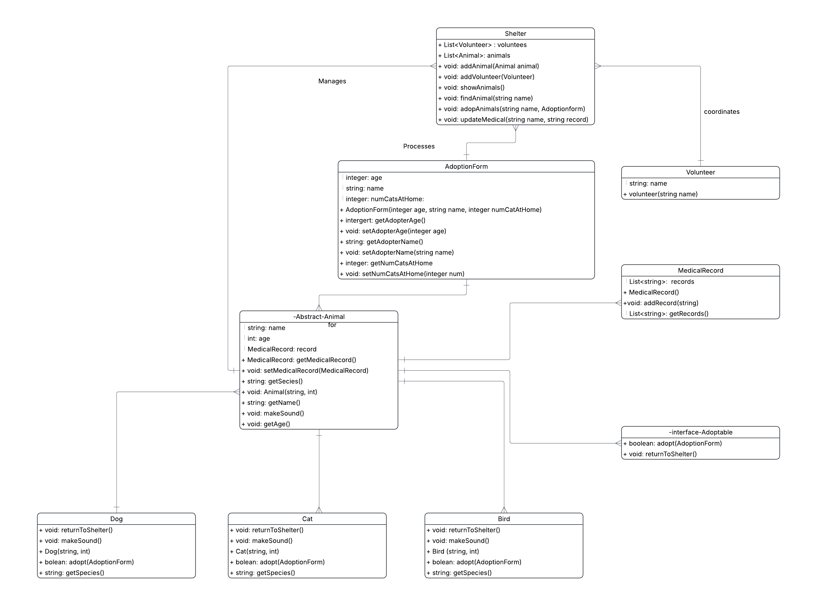
- Sequence Diagram

- Key flow: User submits an AdoptionForm → Shelter finds Animal → Animal checks eligibility via adopt() → If eligible, animal is removed from shelter and adoption confirmed → Otherwise, adoption denied.

- Implementation Plan
  - Package Structure:
- model: This package will contain, in our group code Animal (abstract class), Dog, Cat, Bird (concrete subclasses), Adoptable (interface), MedicalRecord, AdoptionForm, and Volunteer.
- service: This package will will contain, in our group code searching, reservation, adoption processing, and other operations. For instance, the Shelter class managing animals and volunteers, adoption procedures, and medical updates.
- UI: This package will contain the user interface logic, including the main class with menu-driven interaction allowing users to interact with the shelter system. In our group code, a main app class like ShelterApp.
  - Development Tasks
Task | Assigned to
Class design (entities and abstraction: Animal, Dog, Cat, Bird, Adoptable, MedicalRecord, AdoptionForm, Volunteer) | Vidian
Service/manager logic (Shelter class, adoption processing, medical updates, volunteer management) | Serge
Search and retrieval features (finding animals by name, filtering by types, eligibility checks) | Serge
User accounts & adoption forms (validating user/adopter information, forms handling) | Vidian
Main UI (ShelterApp) – menu-driven, displays, main loop, user feedback | Vidian
Testing (unit and scenario tests, edge cases) | Stephen
Documentation (code comments, user guide, developer notes) | Everyone (shared)

- Implementation Plan
- Testing Plan

- Test Scenarios:
- Successful adoption with different conditions
- Displaying several animals, updating and retrieving medical records.
- Edge Cases:
- Adopting an already adopted animal,
- Adopting a bird with more than one cat at home
- Updating medical records of a non-existent animal.
- Reflection Questions
- Polymorphism simplifies handling by allowing different animal types to be treated via the same interface, facilitating extensibility and maintenance.
- Composition is preferred over inheritance for managing collections (like for MedicalRecord) because it allows more flexible and reusable design.
- The main challenge was ensuring correct implementation of abstract methods and interfaces across diverse subclasses, guaranteeing clear and disciplined design.
- References
- Oracle Java Documentation
- Baeldung Java Tutorials
- freeCodeCamp Java OOP Guides
- Google Gemini and Copilot

